5.2.2 Line Integrals Worksheet

- Let C be the curve in parameterized by for .
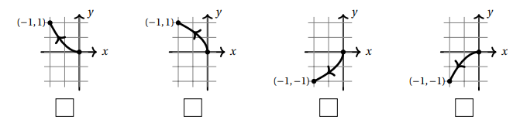
- Mark the picture of C from among the choices below.

- For the vector field compute .

- Find the work done by the force field on a particle that moves along the cosine curve from to .

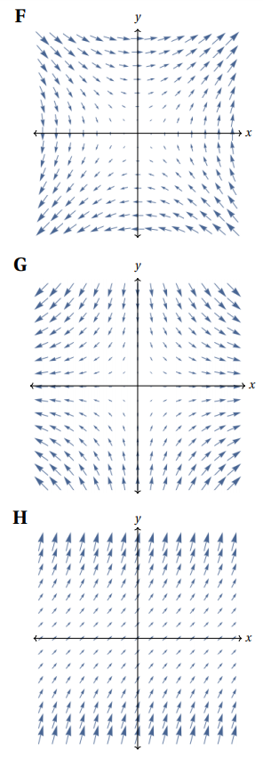
- Three continuous vector fields F,G, H on are plotted below in the region with and . Circle the best response for each of the following questions.
- Which vector field represents , where .
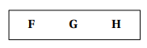

- A particle moves along a straight line from to . If the vector fields represent force fields, then:

The work done by G on the particle is…
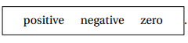

The work done by H on the particle is…


- Find , where and C is the path along the circle of radius 3 starting at the point and ending at the point while moving clockwise.

- Consider the curve C parameterized by where .
- Check the box next to the correct sketch of C.

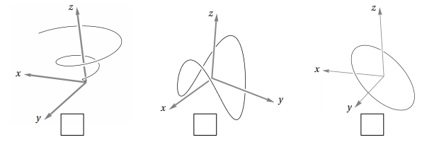

- Find the work done if a particle travels along path under the force given by the vector field .

- Let C be the helix parameterized by where .
- Let be the vector field defined by . Determine when C is oriented in the direction from to .

- Now let . Determine when C is given the opposite orientation.

- Find the work done by the force field on a particle that moves along the parabola from to and then along the line segment from to .

- Evaluate the line integral where and C is the arc of the circle traversed counterclockwise from to .
- Evaluate this line integral in its current form using the formula .

- Rewrite the integral in the form of .

- Evaluate the integral in the form of .

- Evaluate the line integral where and C is given by the vector function where .
- Evaluate this line integral in its current form using the formula .

- Rewrite the integral in the form of .

- Evaluate the integral in the form of .

- Consider the line integral where C is given by the vector function where .
- Evaluate this line integral in its current form.

- Rewrite the integral in the form of . What is F? What is ?

- Evaluate the integral in the form of using the formula .

- Consider the integral where C is given by the vector function where .
- Evaluate this line integral in its current form.

- Rewrite the integral in the form of . What is F? What is ?

- Evaluate the integral in the form of using the formula .

